This Seed Project sends us an annual report describing its ongoing commitments and other activities. The purpose of this project is to provide financial support for those in need.

From the annual report we know this project should have repetitive expenditures related to providing elder care for Wanda Thomas and providing dinners for a group of homeless teenagers. The annual report also mentions various single contributions made throughout the year and describes the non profit nature of each contribution.

To report the project's accounting for the year it submits a copy of the year's bank statements and checkbook register (see a 3 month sample below).

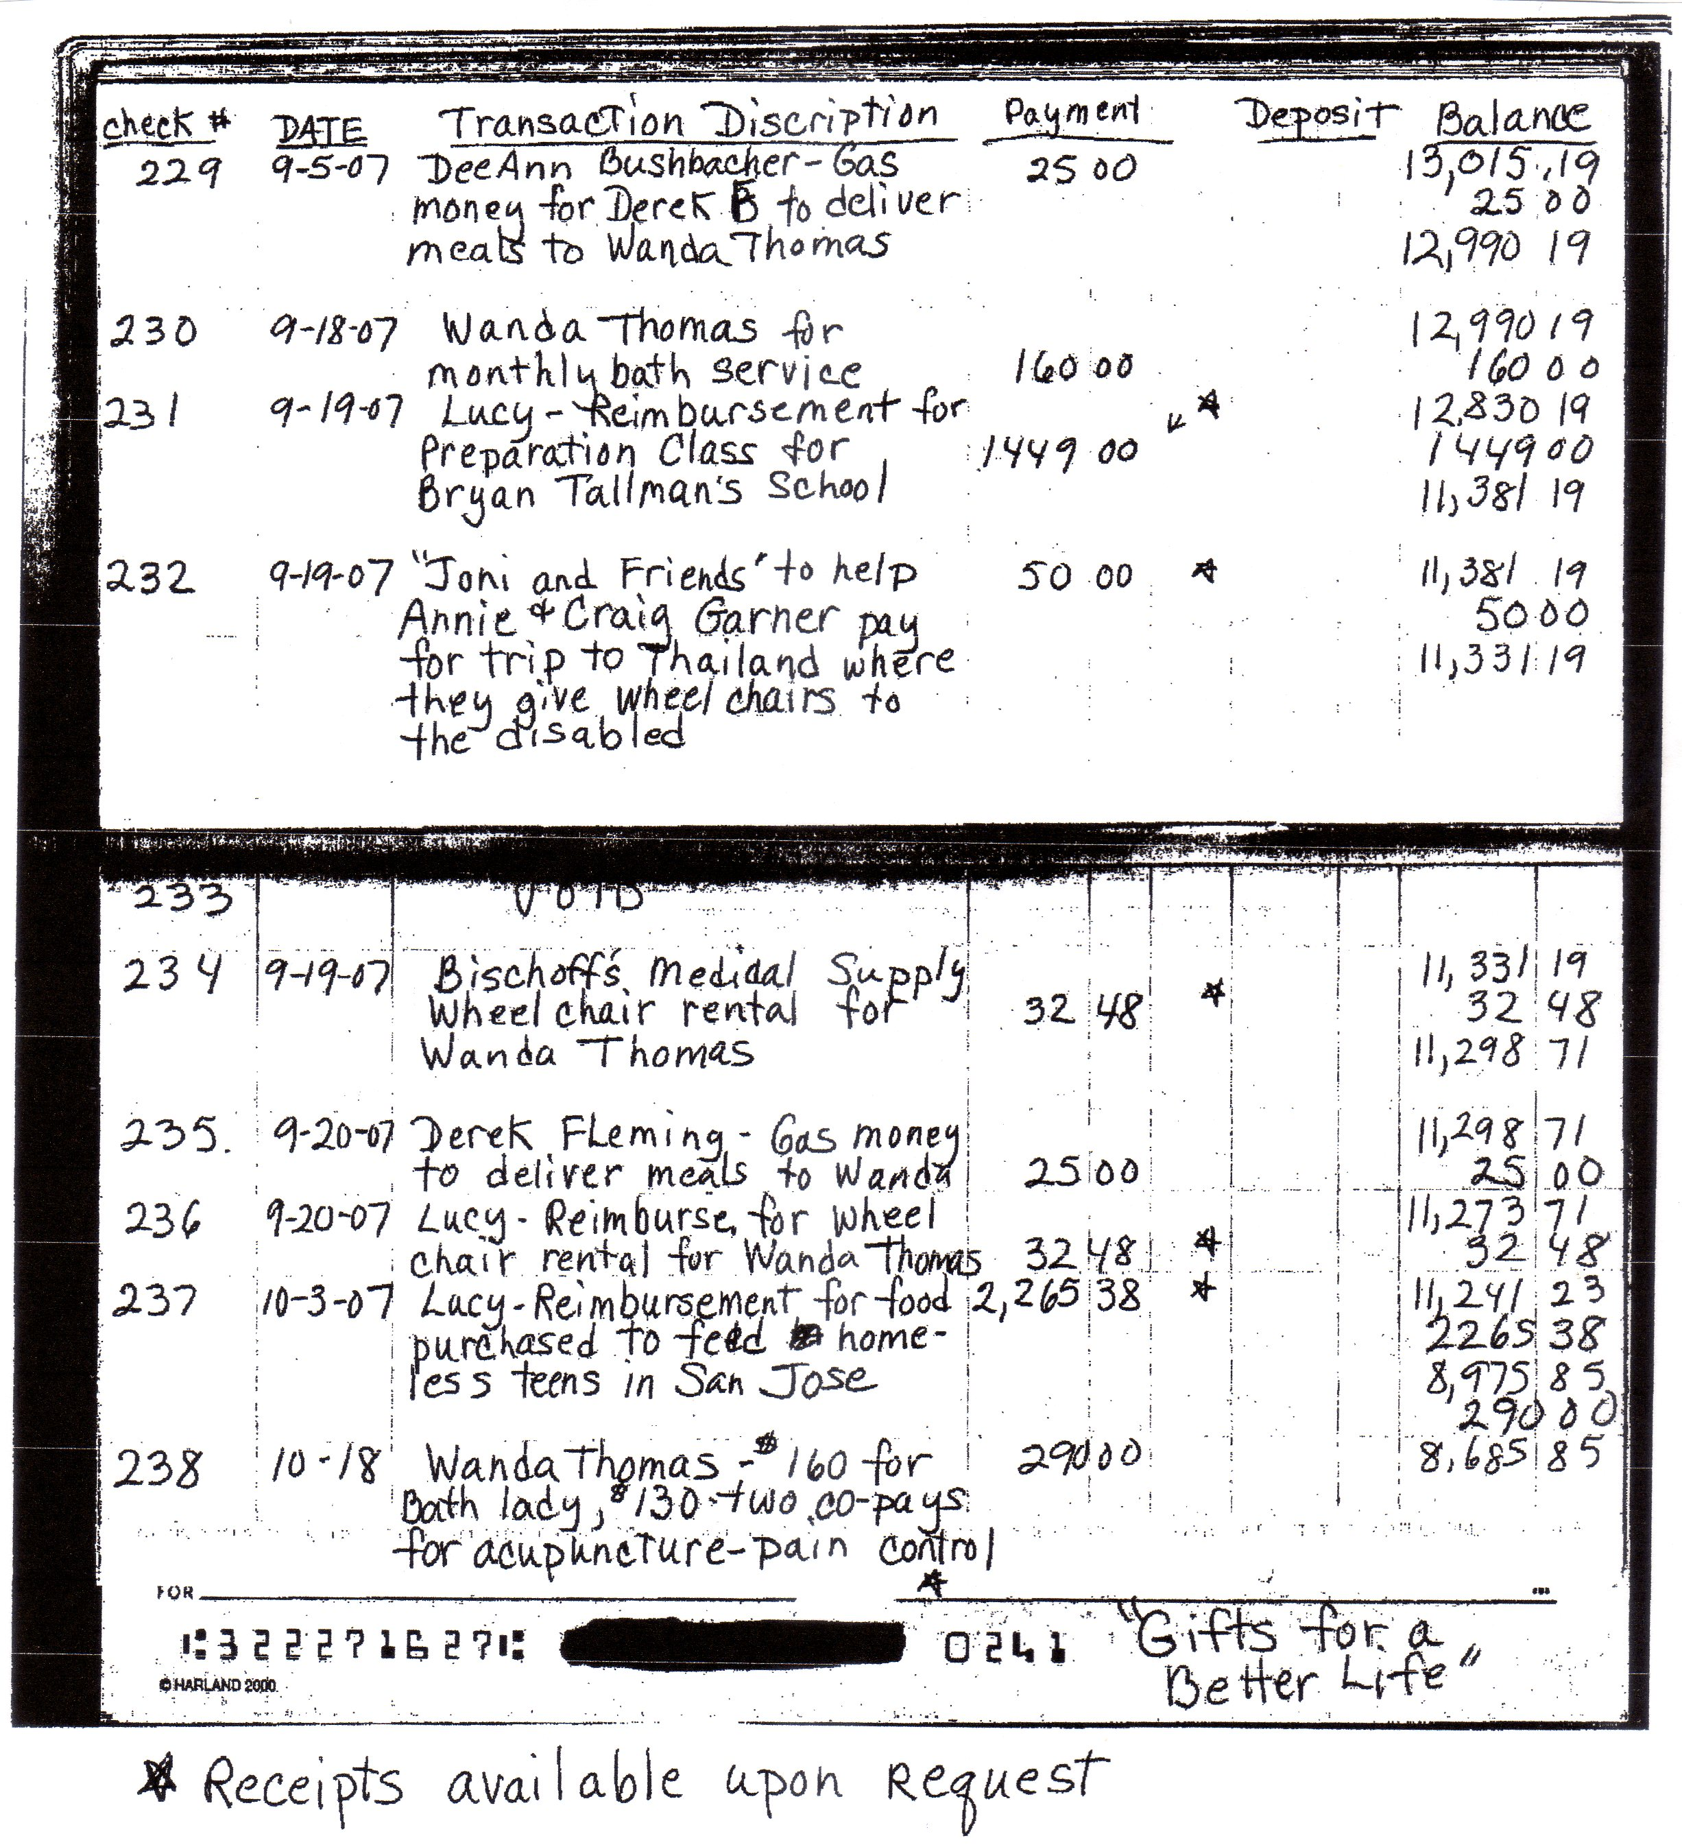

The details in the memo portion of the checkbook register identify the expenditures for the various activities described in the project's annual report.

The project's two ongoing commitments are visible in the repetitive expenditures for various items to provide eldercare for Wanda Thomas and to provide the dinners for the teenagers. The single expenditures are identified to link them to descriptions given in the annual report. An example of this is check number 237, identified as reimbursement to a student for tuition fees. The non profit intention of this was explained in the project's annual report.

Note that each check includes the details needed to identify the expenditure. You need to write similar details in your checkbook register or other accounting journals.

